## Introduction: Business Problem

The objective of the project is finding a location for my Yoga Studio in Toronto. For this purpose I'm going to study the different neighborhoods, to check if they already have a Yoga Studio, and the characteristics of the neighborhood, to find the most convenient.

## Data will be

The information & Data used in the project:

* Number of venues and their type and location in every neighborhood will be obtained using Foursquare API
* coordinate of Toronto center will be obtained using Google Maps API geocoding
* url - <https://en.wikipedia.org/wiki/List_of_postal_codes_of_Canada:_M> for extracting data

## Methodology

First, I am going to get the neighborhoods of Toronto and its location using BeautifulSoup from Wikipedia. The results are plotted in this map:

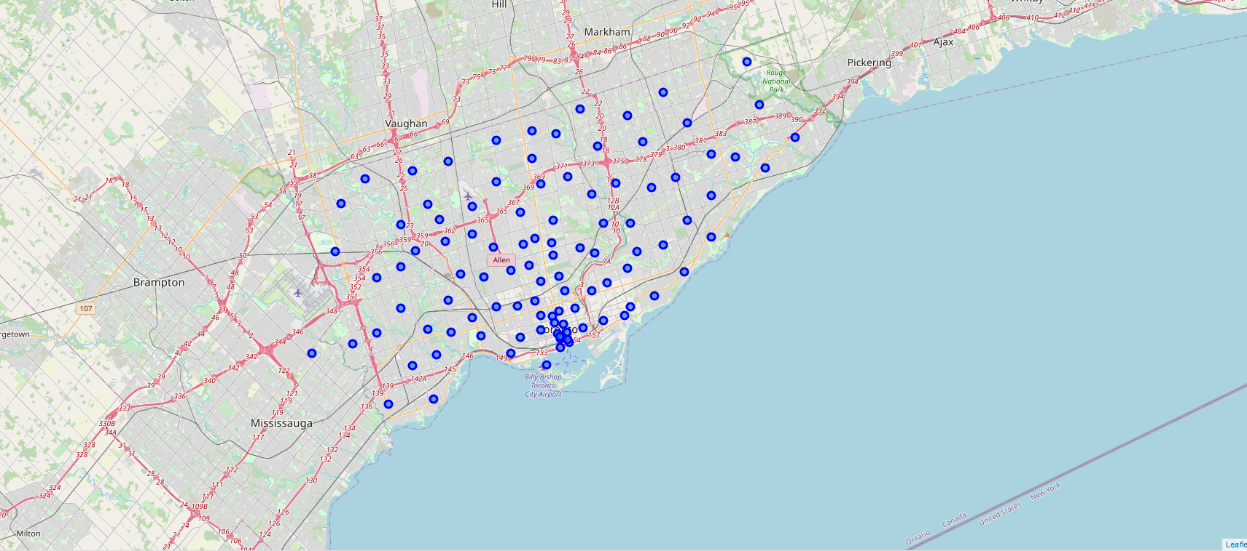

Once I got them, I'm going to retrieve the information of venues and commercial activity in the area using FourSquare. The 10 first rows for the dataframe obtained could are showed here:

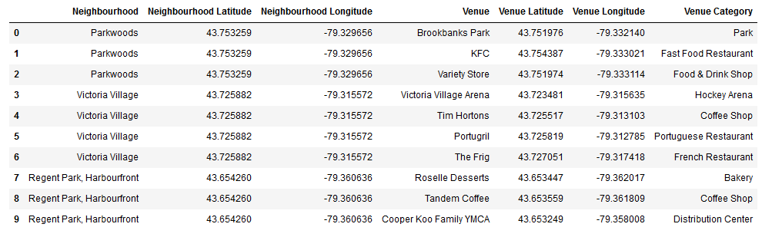

For all the Venues categories, I am going to find those related with Yoga: **Yoga Studio.**

**We obtain 13 Yoga Studios in Toronto**. We are going to plot the Yoga Studios in the map:

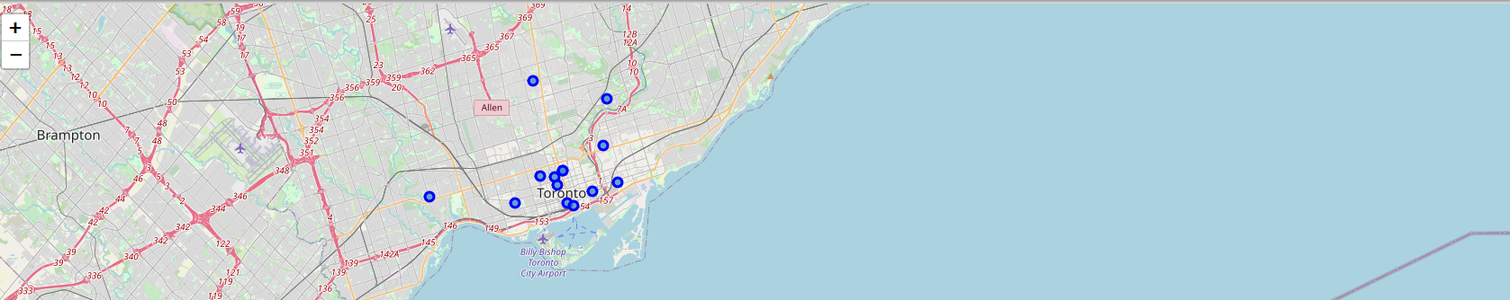

Then, I am going to filter the neighborhoods without Yoga Studios as we don't want competence in the neighborhood. **We obtained 89 neighborhoods suitable for our Studio**.

Now, we are going to decide which is more convenient. First, we are going to find where the vegetarians and vegan restaurants are located, as its public could be potential public for our Yoga Studio. Besides, we could do some publicity campaigns in the restaurants and surroundings to attract people to our Yoga Studio.

**The Venue category associated is: Vegetarian / Vegan Restaurant, and there are 17 in Toronto**.

We are going to match the location of the restaurants with our neighborhoods without Yoga Studios, to check if there is any area without Yoga Studio which has vegan restaurants in the surroundings.

We use groupby, to count the number of veg restaurants by neighborhood:



And we sort the table to get which area has more vegan restaurants.

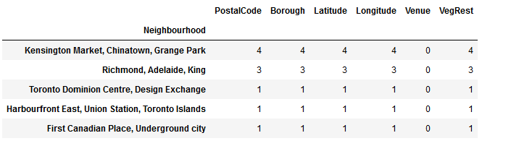

## Results

There are 2 neughbourhoods without Yoga Studio and 3-4 Vegetarian restaurantes:

* Kensington Market, Chinatown, Grange Park
* Richmond, Adelaide, King for analysis

Both seem a great location for our Studio. For determine which one is more convenient we will study the characteristics of the neighborhoods (the type of shops, restaurants and venues).

For this purpose, we are going to retrieve all the information from venues from FourSquares, and make a report of the 5 more frequent venues in each area:

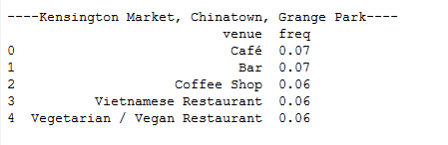

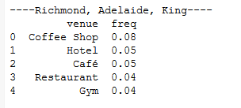

## Discussion

“Kensington Market, Chinatown, Grange Park”, has many coffees and Asian and vegetarian restaurants as most common venues. People who enjoy these venues could potentially like Yoga, as Asian food is healthier than other types off restaurants.

However, “Richmond, Adelaide, King”, has a high concentration of gyms (that could be competence for our Studio) and hotels that could mean that it is a tourist or business area (with not local people which is our target public).

## Conclusion

The best place for our Yoga Studio is “**Kensington Market, Chinatown, Grange Park**” neighbourhood.